**PRAKTIKUM ALGORITMA dan PEMROGRAMAN**

**PRAKTIKUM 11: TOPIK LANJUT (PROGRAM GUI)**



**Disusun Oleh:**

**AS’AD NIROT AHMADI**

**L200220155**

**PROGRAM STUDI TEKNIK INFORMATIKA**

**FAKULTAS KOMUNIKASI DAN INFORMATIKA**

**UNIVERSITAS MUHAMMADIYAH SURAKARTA**

**TAHUN 2022/2023**

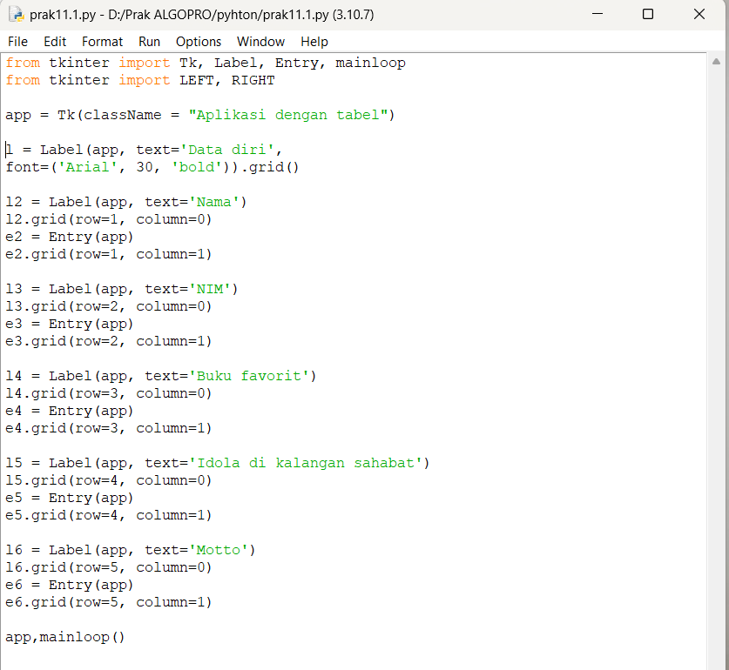**Kegiatan 1. Menampilkan data diri**

**Kode program:**

from tkinter import Tk, Label, Entry, mainloop

from tkinter import LEFT, RIGHT

app = Tk(className = "Aplikasi dengan tabel")

l = Label(app, text='Data diri',

font=('Arial', 30, 'bold')).grid()

l2 = Label(app, text='Nama')

l2.grid(row=1, column=0)

e2 = Entry(app)

e2.grid(row=1, column=1)

l3 = Label(app, text='NIM')

l3.grid(row=2, column=0)

e3 = Entry(app)

e3.grid(row=2, column=1)

l4 = Label(app, text='Buku favorit')

l4.grid(row=3, column=0)

e4 = Entry(app)

e4.grid(row=3, column=1)

l5 = Label(app, text='Idola di kalangan sahabat')

l5.grid(row=4, column=0)

e5 = Entry(app)

e5.grid(row=4, column=1)

l6 = Label(app, text='Motto')

l6.grid(row=5, column=0)

e6 = Entry(app)

e6.grid(row=5, column=1)

app,mainloop()

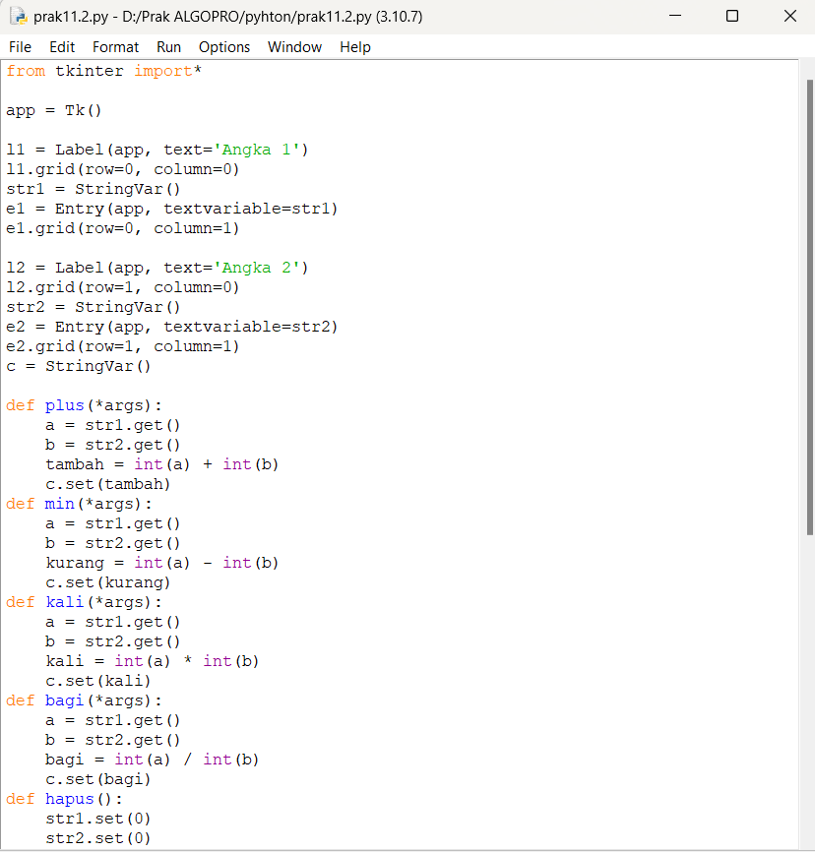**Kegiatan 2. Membuat kalkulator sederhana**

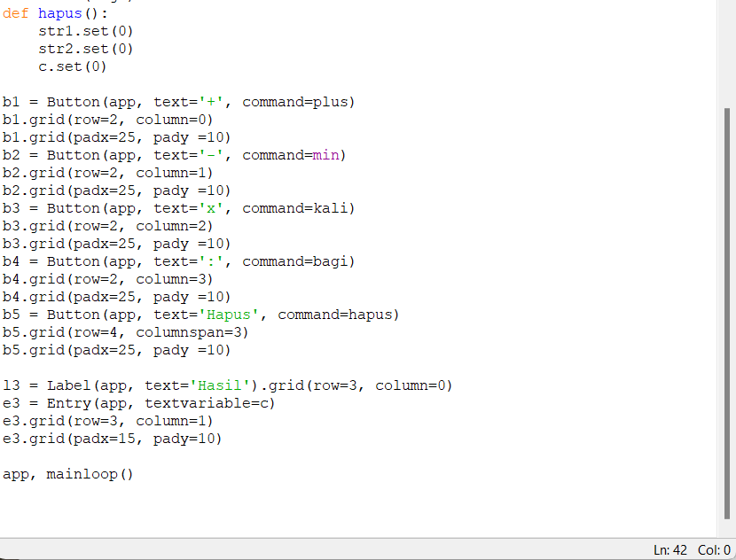

**Kode program:**

from tkinter import*

app = Tk()

l1 = Label(app, text='Angka 1')

l1.grid(row=0, column=0)

str1 = StringVar()

e1 = Entry(app, textvariable=str1)

e1.grid(row=0, column=1)

l2 = Label(app, text='Angka 2')

l2.grid(row=1, column=0)

str2 = StringVar()

e2 = Entry(app, textvariable=str2)

e2.grid(row=1, column=1)

c = StringVar()

def plus(*args):

a = str1.get()

b = str2.get()

tambah = int(a) + int(b)

c.set(tambah)

def min(*args):

a = str1.get()

b = str2.get()

kurang = int(a) - int(b)

c.set(kurang)

def kali(*args):

a = str1.get()

b = str2.get()

kali = int(a) * int(b)

c.set(kali)

def bagi(*args):

a = str1.get()

b = str2.get()

bagi = int(a) / int(b)

c.set(bagi)

def hapus():

str1.set(0)

str2.set(0)

c.set(0)

b1 = Button(app, text='+', command=plus)

b1.grid(row=2, column=0)

b1.grid(padx=25, pady =10)

b2 = Button(app, text='-', command=min)

b2.grid(row=2, column=1)

b2.grid(padx=25, pady =10)

b3 = Button(app, text='x', command=kali)

b3.grid(row=2, column=2)

b3.grid(padx=25, pady =10)

b4 = Button(app, text=':', command=bagi)

b4.grid(row=2, column=3)

b4.grid(padx=25, pady =10)

b5 = Button(app, text='Hapus', command=hapus)

b5.grid(row=4, columnspan=3)

b5.grid(padx=25, pady =10)

l3 = Label(app, text='Hasil').grid(row=3, column=0)

e3 = Entry(app, textvariable=c)

e3.grid(row=3, column=1)

e3.grid(padx=15, pady=10)

app, mainloop()

**Kegiatan 3. Menghitung luas bangun geometri**

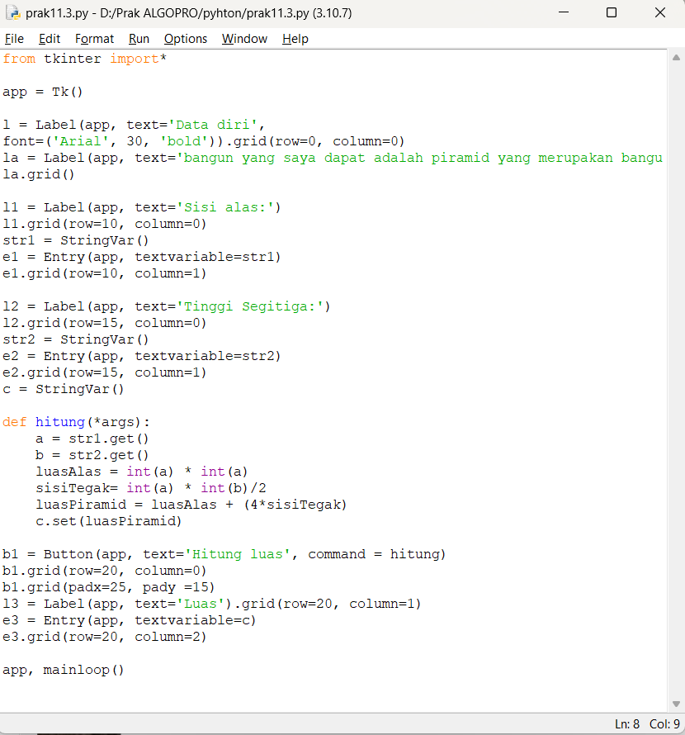

**Kode program:**

from tkinter import*

app = Tk()

l = Label(app, text='Data diri',

font=('Arial', 30, 'bold')).grid(row=0, column=0)

la = Label(app, text='bangun yang saya dapat adalah piramid yang merupakan bangun ruang limas segi empat')

la.grid()

l1 = Label(app, text='Sisi alas:')

l1.grid(row=10, column=0)

str1 = StringVar()

e1 = Entry(app, textvariable=str1)

e1.grid(row=10, column=1)

l2 = Label(app, text='Tinggi Segitiga:')

l2.grid(row=15, column=0)

str2 = StringVar()

e2 = Entry(app, textvariable=str2)

e2.grid(row=15, column=1)

c = StringVar()

def hitung(*args):

a = str1.get()

b = str2.get()

luasAlas = int(a) * int(a)

sisiTegak= int(a) * int(b)/2

luasPiramid = luasAlas + (4*sisiTegak)

c.set(luasPiramid)

b1 = Button(app, text='Hitung luas', command = hitung)

b1.grid(row=20, column=0)

b1.grid(padx=25, pady =15)

l3 = Label(app, text='Luas').grid(row=20, column=1)

e3 = Entry(app, textvariable=c)

e3.grid(row=20, column=2)

app, mainloop()